Group 06 RationalGRL

Page 2................ GRL Model constructed from discussion

Page 3................ Statistics of the annotation

Page 4-11......... Discussion of some interesting GRL elements and their underlying arguments.*

*We only display the interesting arguments. Those that were straightforward have been omitted but are similar to those of Group 00.

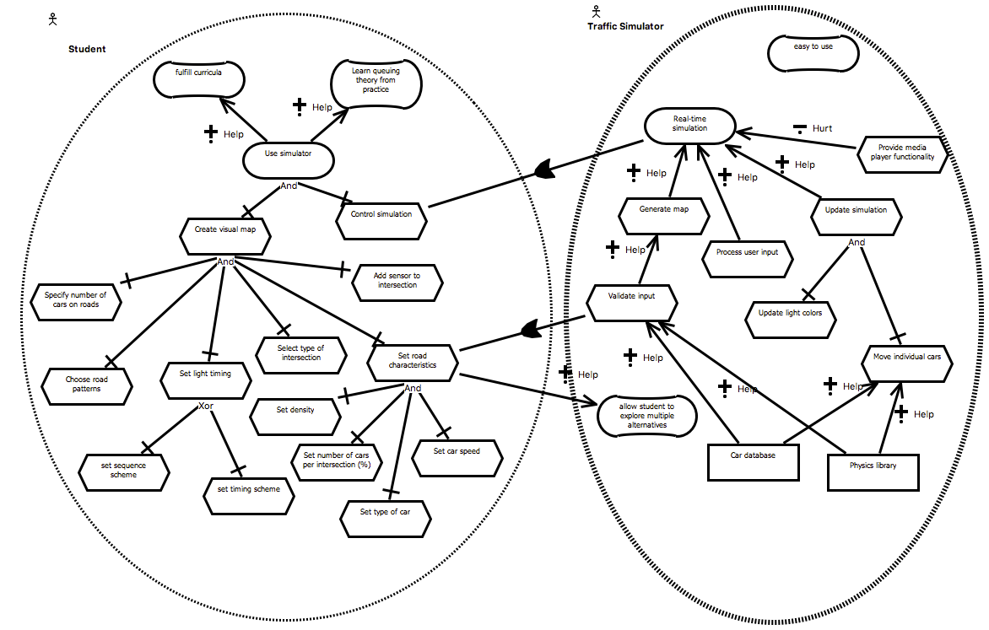 **Statistics**

|  |  |  |  |  |  |  |  |  |  |  |  |  |  |  |  |  |  |  |  |  |  |  |  |  |  |  |  |  |  |  |  |  |  |  |  |  |  |  |  |  |  |  |  |  |  |  |  |  |  |  |  |  |  |  |  |  |  |  |  |  |  |  |  |  |  |  |  |  |  |  |  |  |  |  |
| --- | --- | --- | --- | --- | --- | --- | --- | --- | --- | --- | --- | --- | --- | --- | --- | --- | --- | --- | --- | --- | --- | --- | --- | --- | --- | --- | --- | --- | --- | --- | --- | --- | --- | --- | --- | --- | --- | --- | --- | --- | --- | --- | --- | --- | --- | --- | --- | --- | --- | --- | --- | --- | --- | --- | --- | --- | --- | --- | --- | --- | --- | --- | --- | --- | --- | --- | --- | --- | --- | --- | --- | --- | --- | --- |
| |  |  |  | | --- | --- | --- | | **Argument Schemes** | **Found** | **Added** | | AS0: Actor | 2 |  | | AS1: Resource | 4 |  | | AS2: Task/action | 21 |  | | AS3: Goal | 2 |  | | AS4: Softgoal | 4 |  | | AS5: Task realizes goal |  |  | | AS6: Task contributes to softgoal | 2 |  | | AS7: Goal contributes to softgoal | 1 |  | | AS8: Resource contributes to task | 4 |  | | AS9: Actor depends on actor | 1 |  | | |  |  | | --- | --- | | **Critical questions** | **Found** | | CQ1: Is the resource available? |  | | CQ2: Is the task possible? | 2 | | CQ3: Can the desired goal be realized? |  | | CQ4: Is the softgoal legitimate? |  | | CQ5a: Will the task realize the goal? |  | | CQ5b: Are there alternative ways to realize the same goal? |  | | CQ6a: Are there alternative ways to contribute to the same softgoal? |  | | CQ6b: Does the task have negative side effects / same softgoal? |  | | CQ6c: Does the task have negative side effects / other softgoal? |  | | CQ6d: Does the task contribute to some other softgoal? |  | | CQ6e: Does the task preclude other task contributing to other softgoal? |  | | CQ7a: Does the goal contribute to the softgoal? |  | | CQ7b: Does the goal contribute to some other softgoal? |  | | CQ8a: Is the resource required in order to perform the task? |  | | CQ8b: Can other resources be used for the task? |  | | CQ8c: Is the resource required in order to perform the task? |  | | CQ8d: Does using the resource make other resources unavailable? |  | | CQ9: Does the actor depend on any actors? |  | | | |
| **Other annotations** | | **Found** |
| GRL-related issue introduction (e.g., "what are the actors?") | |  |
| AS: Task x-decomposes into task (x in {XOR,AND,OR}) | | 14 |
| AS: Task contributes negatively to softgoal | | 1 |
| CQ: Is the task is useful/relevant? If no: remove task | | 1 |
| CQ: Is the description of an IE clear? (clarification). If no: replace description | | 6 |
| CQ: Is the description of the IE specific enough? If no: replace description | | 4 |
| CQ: Does the task decompose into the other task? | | 2 |
| CQ: What kind of decomposition (AND/OR/XOR)? | |  |
| Counterargument | | 2 |
| CQ: does the task contribute to the goal? | | 1 |

**Student Task "Create a car": Multiple Critical Questions**

|  |  |  |
| --- | --- | --- |
| 0:17:45.7  PERSON 2 | Create a car | **[16 task (AS2)]** Student has task "Create a car" |
| 0:17:47.8  PERSON 1 | Ok |  |
| 0:17:48.3  PERSON 2 | Really? |  |
| 0:17:49.9  PERSON 3 | Yeah sure. I think it should be because you need to place cars and then you also, I’m guessing |  |
| 0:17:58.0  PERSON 1 | Do you actually- I was under the assumption that they were only busy with roads and traffic lights, and not necessarily cars as entities. | **[17 critical question CQ2 on 16]** Is the task "Create a car" possible?  **[18 answer to 17]** No, students are only busy with roads and traffic lights, and not cars as entities.  **[18a remove]** Task "Create a car" is removed. |
| 0:18:07.7  PERSON 3 | Yes, because you need a model of how the cars will flow evenly through the intersections. So you need to time everything, but you still need the entity that will travel on the simulation to show that you’ve actually done something- | **[19 counter argument to 18]** You need a model of how cars will flow through the simulation. |
| 0:19:59.5  PERSON 3 | So create a car, maybe we can set a create car. Specify number of cars, that would be, I guess, better. Because you don’t necessarily create a car but you would more specify. | **[24 critical question CQ?? for 16]** Is the task "Create a car" specific enough?  **[25 answer to 20]** No. You may choose to depict inidividual cars or use more abstract.  **[25a rename]** replace "Create a car" with "Specify the number of cars on roads" |
| 0:20:15.8  PERSON 2 | Specify |
| 0:20:16.6  PERSON 3 | Entity number |

MacintoschHD:Users:marc.vanzee:Desktop:Screen Shot 2016-12-16 at 12.44.46.png**Student: "Create road": Iterative refinement**

*18. Impossible task (CQ2)*

*25. Specification (CQ?)*

AS2: Actor "Student" has Task "Create a car"

Actor "Student" does not have Task "Create a car"

AS2: Actor "Student" has Task "Specify number of cars on roads"

Cars are entities in the simulation so students do care about it.

|  |  |  |
| --- | --- | --- |
| 0:17:39.5  PERSON 1 | And in that process there are activities like create a visual map, create a road | **[14 task (AS2)]** Student has task "Create road" |
| 0:24:36.0  PERSON 3 | And, well interaction. Visualization sorry. Or interaction, I don’t know. So create a visual map would have laying out roads and a pattern of their choosing. So this would be first, would be choose a pattern. | **[31 critical question CQ?? for 14]** Is Task "Create road" clear?  **[32 answer to 31]** no, according to the specification the student should choose a pattern.  **[32a rename]** "Create road" becomes "Choose a pattern" |
| 0:24:55.4  PERSON 1 | How do you mean, choose a pattern |
| 0:24:57.5  PERSON 3 | Students must be able to create a visual map of an area, laying out roads in a pattern of their choosing |
| 0:25:07.5  PERSON 1 | Yeah I’m not sure if they mean that. I don’t know what they mean by pattern in this case. I thought you could just pick roads, varying sizes and like, broads of roads. | **[33 critical question CQ?? for 32a]** Is "Choose a pattern" specific enough?  **[34 answer to 33]** No, I am not sure what they mean by a pattern. |
| 0:25:26.0  PERSON 3 | No yeah exactly, but you would have them provide, it’s a pattern, it’s a different type of road but essentially you would select- how would you call them, selecting a- | **[34a rename]** "Choose a pattern" becomes "Choose a pattern preference". |
| 0:25:36.3  PERSON 1 | Yeah, selecting a- I don’t know |
| 0:25:38.0  PERSON 3 | Pattern preference maybe? As in, maybe we can explain this in the documentation |
| 0:25:43.9  PERSON 1 | What kind of patterns though. Would you be able to select | **[35 critical question CQ?? for 34a]** Is "Choose a pattern preference" clear?  **[36 answer to 35]** no, what kind of pattern? |
| 0:25:47.4  PERSON 3 | Maybe, I don’t know it’s- | **[36a rename]** "Choose a pattern preference becomes "Choose a road pattern" |
| 0:25:48.5  PERSON 1 | [inaudible] a road pattern |

AS2: Actor "Student" has Task "Choose a pattern preference"

AS2: Actor "Student" has Task "Choose a road pattern"

AS2: Actor "Student" has Task "Choose a pattern"

AS2: Actor "Student" has Task "Create road"

*32. Clarification (CQ?)*

*36. Clarification (CQ?)*

*34. Specification (CQ?)*



**Student: Complex interactions of critical questions**

|  |  |  |
| --- | --- | --- |
| 0:44:44.2  PERSON 3 | You would press start you could specify, yeah ok, the average speed of the cars is thirty point whatever, the density of cars coming into each of the intersections is 1.5 per second. And, I don’t know, some other parameters that might be- maybe even the sequence of the lights, that might- | **[54 task (AS2)]** User Student has task "set car density". |
| 0:45:17.6  PERSON 3 | That would be specify density | **[58 critical question CQ?? for 57b]** Is "set car density" clear?  **[59 answer to 58]** no.  **[59a rename]** "set car density" becomes "specify traffic density" |
| 0:45:19.8  PERSON 1 | Traffic density yeah |
| 0:45:21.3  PERSON 3 | Specify traffic density |
| 0:46:28.0  PERSON 1 | Sure, but I- what kind of option do we give. The users. | **[60 critical question for 59a]** is "set traffic density" specific enough?  **[61 answer to 60]** no  **[61a rename]** "set traffic density" becomes "set traffic density (number of cars per road)" |
| 0:46:33.0  PERSON 3 | Specify the road characteristics? |
| 0:46:35.4  PERSON 1 | Just like a number? |
| 0:46:36.8  PERSON 3 | Mhm |
| 0:46:37.2  PERSON 1 | Like an integer? |
| 0:46:39.5  PERSON 3 | I guess that’s the easiest. How else would you specify, I don’t know, how would you specify if this was a simulation. I think you would start, how many cars will enter this road. And you would say 30 and you would see how much that is and you would go back and you would specify, I don’t know, 50, because it wasn’t enough. |
| 0:46:58.6  PERSON 1 | So we just give them- just gonna enter an integer, the amount of- |  |
| 0:47:03.9  PERSON 3 | Yeah I would go for a number of cars, the density of the cars and average speed maybe. Something- but that can also be done with the help of those mathematical functions as in, I don’t know, average speed on the highway, average speed in a- what do you call it- suburban area or whatever. But I think that’s just input that we could give when they create a map or before the start of the simulation. |  |
| 0:47:38.7  PERSON 1 | Yeah, so I - | **[62 critical question CQ?? for 61a]** Can "set traffic density (number of cars per road)" be abstracted an decomposed into subtasks?  **[63 answer to 62]** Yes, it is more generally "road characteristics", which is decomposed into three actions.  **[63a rename]** "set traffic density (number of cars per road)" becomes "set road characteristics"  **[63b task (AS2)]** Student has tasks "density", "speed", and "number of cars"  **[63c decomposition (AS??)]** Task "set road characteristics" decomposes into " density", "speed", and "number of cars". |
| 0:47:39.0  PERSON 3 | Ok. So you start a simulation, you would- ok, before you display it you would have these two. So specify the road characteristics, no, maybe just this one. So you specify the traffic characteristics basically, that would- so traffic characteristics. And that would be the density, speed, and what else did we say. Number of cars |
| 0:48:20.4  PERSON 1 | Density, speed and number of cars. But isn’t density- | **[64 critical question CQ?? for 63c]** Is task "density" redundant?  **[65 answer to 64]** yes, it is a synonym for "number of cars"  **[65a remove]** task "density" is removed |
| 0:48:23.3  PERSON 3 | Yeah exactly |
| 0:48:23.8  PERSON 1 | Number of cars, it’s the same |
| 0:48:27.5  PERSON 3 | What if we specify the number of cars per intersection maybe. I mean as in percentages. For example if you have three hundred cars, and you have ten intersections, if three hundred cars will go from one end, imagine this is a straight road | **[66 critical question CQ?? for 63c]** Is "number of cars" specific enough?  **[67 answer to 66]** No.  **[67a rename]** "number of cars" becomes "number of cars per intersection (%)" |
| 0:49:05.3  PERSON 3 | So, density, speed and, is there anything else. | **[68 critical question for 63c]** Does "set road characteristics" decompose into any other tasks?  **[69 anwer to 68]** Yes, type of cars.  **[69a task (AS2)]** Student has task "set type of cars"  **[69b decomposition (AS??)]** Task "set road characteristics" decomposes into "set type of cars" |
| 0:49:09.7  PERSON 1 | No, speed, density |
| 0:49:20.1  PERSON 3 | Maybe type of cars |
| 0:49:21.5  PERSON 1 | Yeah |
| 0:49:22.0  PERSON 3 | Type of cars, because you could have trucks, you could have personal cars. That would be good because- |

AS2: Actor "Student" has Task "Set road characteristics"

AS2: Actor "Student" has Task "Specify traffic density"

AS2: Actor "Student" has Task "Density of cars"

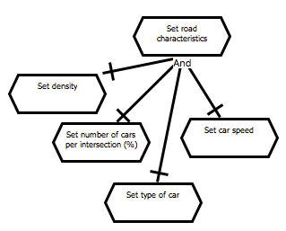

*Decomposition (CQ?)*

*69. Additional task (CQ?) "Type of cars"*

*64. Redundancy (CQ?)*

*66. Specification (CQ?)*

*61. Specification (CQ?)*

*59. Clarification (CQ?)*

AS?: Task "set road characteristics" AND- decomposes into tasks "density", "speed", "number of cars", and "type of cars"

AS2: Actor "Student" has Task "Set type of cars"

*Decomposition*

AS2: Actor "Student" has Task "Set speed"

AS2: Actor "Student" has Task "Set density"

AS?: Task "set road characteristics" AND- decomposes into tasks "density", "speed", and "number of cars"

AS2: Actor "Student" has Task "Set number of cars"

AS2: Actor "Student" does not have Task "Set density"

AS2: Actor "Student" has Task "Set number of cars per intersection (%)"